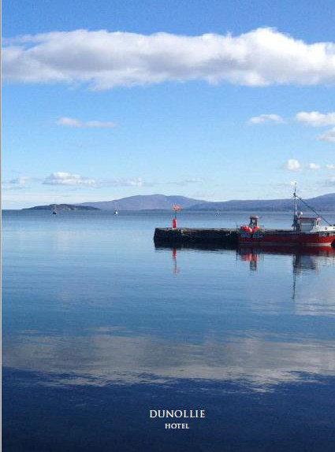

VEGAN MENU

TO START

**Soup of The Day Bruschetta**

Cheese, Fresh Tomato,

Onion, Basil & Balsamic Glaze

**Onion Bhaji**

Mixed Salad with Olive Oil, Sweet Chilli Dip

**Garlic Mushrooms**

Creamy Garlic Sauce, Garlic Bread

**Nachos**

Melted Cheese & Salsa

**£5.50**

**£6.50**

**£6.25**

**£7.00**

**£6.25**

MAIN

**Falafel & Spinach Burger**

Burger Bun with Tomato, Lettuce, Onion, Salsa & Chips

**£12.75**

**Add** Cheese & Onion Rings

**Vegetable Balti Curry** Boiled Rice & Poppadum **Sausage & Mash**

Season Vegetable, Onion Gravy

**Pasta in Tomato & Vegetable Sauce**

Garlic Bread

**Mushrooms & Pea Risotto**

**supplement**

**£2.50**

**£12.50**

**£12.00**

**£11.00**

**£11.75**

TO FINISH

**Chocolate Orange Cake**

Vanilla Ice Cream

**Duo of Raspberry & Orange Sorbet Sticky Toffee Pudding**

Vanilla Ice Cream

**£6.50**

**£4.50**

**£6.75**

IMPORTANT INFORMATION: All our food is prepared in a kitchen where nuts, gluten and other known allergies may be present. Please note we take every caution to prevent cross-contamination, however, any product may contain traces as our entire menu is produced in the same kitchen.

We advise you to speak to a member of the team if you have any food allergies or intolerances. Full allergen information for each dish is available on request.