





**BATTERED FISH & CHIPS**

CHICKEN GOUJONS & CHIPS

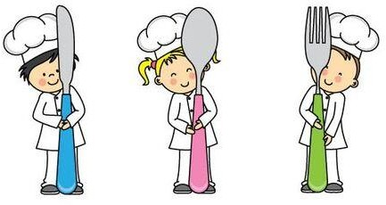

**\*\*\* Please ask for any sauce when ordering \*\*\***



**1 COURSE - £6.50 2 COURSE - £10.00**

**3 COURSE - £12.00**