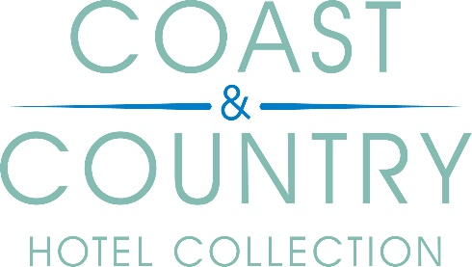

COUNTY CHAMPION
TERMS AND CONDITIONS

- The selection process will be conducted from all the entries submitted by the deadline date (please check the website for individual regional closing dates)
- The winner will be contacted via email to accept the role of County Champion
- In return for the County Champions input, we will offer the choice of either a monetary payment of £350 OR a 2-night break at a hotel(s) of your choice within the Coast & Country Hotel Collection.
- The payment and 2-night break option are non-changeable, non-exchangeable and non-transferable
- The 2-night break consists of bed and breakfast for two people sharing a standard twin or double room
- The 2-night break must be redeemed by 31st December 2023 (excluding July, August and Christmas and New Year period)
- Advance booking is required and stay dates are subject to availability
- The monetary value of £350 will be split into two payments. £175 will be paid at the start of the project and the balance will be paid on completion of the work
- The successful County Champion applicant will be expected to:
  - List their favourite places in the region, hidden gems, top tips for visitors which will help form a suggested itinerary for the website.
  - Allow the use of the County Champion's name and county information across all marketing channels, including but not limited to PR, website, social media and blog.
- Any person who is an employee or an immediate family member of an employee of the Coast & Country Hotel Collection and Bespoke Hotels Ltd or any other person who is directly connected with the organisation is not eligible to participate.
- The prize draw is open to people aged 18 and over.

- No responsibility will be taken for details that are ineligible or received after the closing date.

- Coast & Country Hotel Collection shall not be liable for any failure to comply with its obligations where the failure is caused by something outside its reasonable control. Such circumstances shall include, but are not limited to, weather conditions, fire, flood, hurricane, strike, industrial dispute, war, hostilities, political unrest, riots, civil commotion, inevitable accidents, supervening legislation, or any other circumstances amounting to force majeure.
- Promoter: Coast & Country Hotel Collection, c/o Bespoke Hotels, 210 Cygnet Court, Centre Park, Warrington, WA1 1PP

Use and Protection of your Personal Information
- Coast & Country Hotel Collection recognises that your privacy is important to you and we will use best practices to secure all personal information.
- Coast & Country Hotel Collection aims to always preserve your privacy and will not disclose your personal information to third parties unless it is required to do so by law.

- These terms and conditions shall be governed by and construed in accordance with the laws of England and Wales. Any dispute arising under these terms and conditions shall be subject to the exclusive jurisdiction of the courts of England and Wales.

